**Observation**

Inspection was undertaken at the subject property to which the following tree impact damage was noted:

1. In schematically illustrating the damaged areas affected by the water ingress, we have provided schematic floor plans of the subject property, highlighting the elements and areas of sustained water damage. *– Refer to* ***Appendix A***

## Observed Damage

1. From our inspection of the internal areas, we noted the following water damage:

### Upper Level (Entry)

1. Water staining to the bulkhead plasterboard lining corresponding to the corner of the fixed window within the Living. **Image 2**

### Middle Level

1. We noted water damage to the floorboards and ceiling lining corresponding to the southwest corner of the Dining. From provided information, water ingress was reported from the glass pane about the existing steel beam protruding the glass pane, supporting the upper balcony. **Images 3 - 6**
2. Water ingress damage to the floorboards and wall linings adjacent to the balcony sliding door corresponding to the front elevation. **Images 7 & 8**
3. Water ingress damage to the floorboards and wall linings adjacent to the balcony bifold doors about the rear elevation. **Images 9 - 11**
4. Water staining to the ceiling lining adjacent to the manhole access panel about the opening between Lounge and Living areas. **Images 12 & 13**

### Lower Level

1. Water ingress damage to the section of carpet overlay along the balcony sliding door within Bedrooms 1 & 2. **Images 14 - 18**
2. Water ingress damage to the section of carpet overlay directly below the window opening within Bedroom 3. **Images 19 & 20**

### Basement Level

1. Water ingress into the Basement area from the junction of the retaining wall/floor against the retained backfill. **Images 21 & 22**

## Assessment of Water Ingress & Damage

1. In ascertaining the cause of water ingress and damage, we undertook inspection and assessment of various internal and external areas throughout the property inclusive of balconies to which we have attributed the underlying cause to the following issues:

### Defective Flashing Between Wall & Fixed Window

1. From our review of the provided Leak Detection Report, subsequent to the completed spray testing, the source of water ingress has been attributed to separation between flashing and window frame.
2. In our opinion, the above finding is consistent with the mechanism and pattern of observed water ingress damage to the bulkhead lining directly below the fixed window about upper (entry) level.
3. In our opinion, during a high-intensity rainfall, the identified separation between flashing and window frame will enable the wind-driven rain to permeate into the internal areas and result in the observed water damage.
4. Considering the above, in our opinion, the cause of water ingress damage to the bulkhead lining within the upper level is due to the defective flashing and **unrelated to any single insurable event**.

### Defective Silicone Sealant About Steel Beam Penetration

1. With reference to the Leak Detection Report, the spray testing of the area above within the balcony, identified water ingress around the existing steel beam penetration within the glass panes.
2. The aforementioned steel beam is supporting the edge of the above balcony.
3. From our inspection, we noted the balcony above consists of a tiled section and timber deck extension about the free edges.
4. We noted evidence of pre-existing and long-term localised water staining to the steel beam top flange directly about the penetration into glass panes.
5. In our opinion, during rainfall, water can permeate through the inherent gap between the above balcony tiling and timber decking and onto the steel beam flange.
6. In saying that, water is able to gradually track laterally through the steel flange due to water capillary action and pool against the sealant around the steel beam penetration within glass panes.
7. We note that external silicone is always susceptible to deterioration from cyclic environmental, weather and thermal exposure over time, and requires ongoing maintenance and reapplication over time.
8. In saying this, any breaches or perforations along the sealant facilitate entry points for water ingress to occur during rainfall over time.
9. As such, in our opinion, subject to defective and deteriorated sealant application around the steel beam, water can permeate into the internal areas as identified through spray testing.

1. In our opinion, the cause of water ingress is attributed to the defective or deteriorated sealant application around the steel beam penetration, which is an inherent maintenance issue **and unrelated to any single insurable event**.

### Omission of Hob/Step-Down and Waterstop Angle at Balcony Doors

1. From our inspection of the balconies about the middle and lower levels, we noted no evidence of adequate step-down or hob between the internal and external areas. **Images 22 - 29**
2. In saying this, the internal finished floor level is relatively continuous with the balcony finished floor level.
3. Moreover, no sign of evidence of an internal waterstop angle about the balcony door sill was noted.
4. Furthermore, we noted evidence of cracked and deteriorated silicone sealant application along the sill of door openings.
5. Inherently, external silicone is always susceptible to deterioration from cyclic environmental, weather and thermal exposure over time, to which its effectiveness is dependent on ongoing maintenance and reapplication over time.
6. In saying this, any breaches or perforations along the sealant facilitate entry points for water ingress to occur during rainfall over time.
7. We refer to *AS4654.2:2012 – Waterproofing Membrane Systems for Exterior Use – Above Ground Level – Part 2: Design and Installation* which requires a set-down to provide a vertical surface as a physical barrier against water ingress into the building inclusive of a sub-sill flashing.
8. In addition, without the installation of a waterstop angle, effective vertical termination of waterproofing measures within the internal floor face cannot be met adequately.
9. A typical detail of waterproofing at external door openings illustrating the above-noted construction requirements has been provided in ***Figure 2***, taken from *AS 4654.2:2012*.

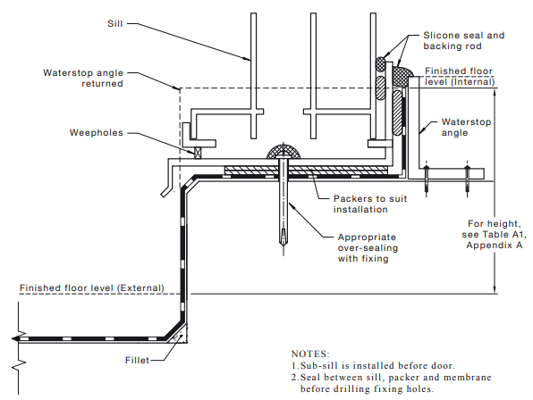

***Figure 2 – Typical Waterproofing Membrane Detail at External Door Openings***

1. We note that during heavy storm events, directional rainfall can pool against the balcony door sill.
2. Consequently, in absence of the abovementioned waterproofing provisions, in our opinion, water is able to gradually track laterally from the balconies and penetrated through the inherent gaps along the door sill and into the internal areas as observed in the middle-level balcony doors and lower-level bedrooms 1 & 2.
3. Consequently, in absence of the abovementioned waterproofing provisions, in our opinion, water is able to gradually track laterally from the balconies and penetrated through the inherent gaps along the door sill and seep down into the internal areas below as observed in the middle-level ceiling lining adjacent to the manhole panel.
4. In remediating the inherent construction defect, in our opinion, it is unfeasible and impractical to introduce a step-down within the balcony at this stage.
5. As a practical alternative, in our opinion, a new strip drain system and downpipe should be retrofitted within the balconies along the sliding doors to mitigate future water ingress into the internal areas.
6. The abovementioned remedial solution will require the engagement of a qualified Hydraulic Engineer to provide a compliant design for sizing of the abovementioned strip drain and downpipe, in accordance with *NCC BCA 2019* and *AS3500.3 – Stormwater Drainage*.
7. In addition, we advise for installation of waterstop angle about the internal face of the balcony door opening.

### Defective Window Sill Flashing

1. From our external inspection of the existing window opening about Bedroom 3 on the lower-level, we noted several windows do not possess any weepholes along the brick course below the window opening to suggest that adequate sub-sill flashing has been installed. **Image 30**
2. We further sighted that the external brickwork window sill does not provide any fall away from the building.
3. In accordance with *Master Builders Australia Waterproofing Guides Book 4 – Flashing and Damp-Proof Courses*, window sills should be sloped at least 15 degrees away from the window to facilitate the drainage of rainwater.
4. A schematic cross-section diagram taken from the abovementioned documentation has been provided within ***Figure 3***.

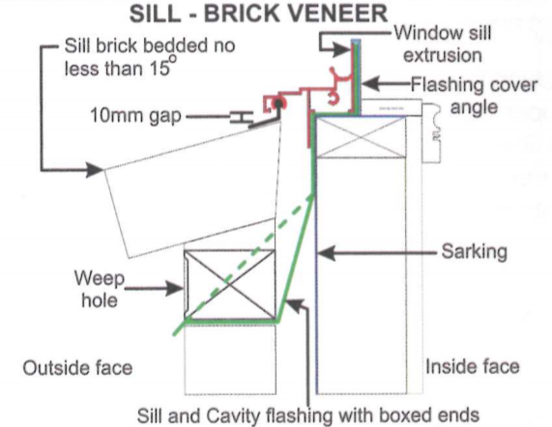

***Figure 3 – Typical Window Sill Detail***

1. Given the inadequate window sill slope, water is able to pond along the window sill during rainfall.
2. In saying that, any defective or non-existence window sill flashing can allow water to subsequently seep underneath the window frame and within the brickwork cavity.
3. Given the absence of weep holes and effective sill and cavity flashing as shown in ***Figure 3*** above, water can track down and pool about the wall and flooring junction.
4. Consequently, during a prolonged heavy rain event as occasioned the area, the trapped water can result in moisture being absorbed by internal brick skin through capillary suction.
5. In our opinion, the observed water ingress about the Bedroom 3 is consistent with inherent construction issues as outlined above and **is not a direct result of the claimed storm or any other single insurable events**.

### Inherent Subterranean Water Ingress into Basement

1. From our inspection of the basement, we noted water ingress occurring mainly about the base of the masonry retaining walls along the front elevation.
2. Given that the basement area is considered a non-habitable area, we envisage that no waterproofing provisions have been provided behind the retaining wall to mitigate subterranean water ingress from the retained backfill.
3. We note that the waterproofing of the masonry retaining wall at the time of original construction was not a requirement of AS 4654.2 and NCC BCA given that the patio space was considered a non-habitable external area.
4. Naturally occurring and flowing sub-surface and subterranean water will be present at all times and during high-intensity rainfall periods saturating the backfill material behind the basement retaining walls.
5. On the assumption that the waterproofing membrane had been provided behind the retaining walls, given the considerable age of the property, we envisage that any waterproofing provisions that had been present would have exceeded the typical 10-15 year lifespan of such products, to which deterioration of the membrane enables subterranean moisture to bypass.
6. Considering the above, given the inherent underground construction of the basement, rising damp and subterranean moisture migration through the porous masonry walls will always be expected to occur over time.
7. In saying that, in our opinion, the above-mentioned issue would always be expected to occur.
8. In mitigating such moisture ingress, we recommend the installation of a negative waterproofing membrane on the internal faces of the perimeter walls.
9. However, in our opinion, such remedial works cannot be completely warranted and are only for the alleviation of such damage, given the partial underground construction and inherent susceptibility to moisture ingress.

**Discussion**

NA

**Conclusion**

From our inspection and assessment, we consider the experienced water ingress throughout the

property to be attributable to a combination of the following issues:

* Defective flashing between Wall & fixed window frame about the upper level, allows wind-driven rainfall to permeate through the exhibited separation and casing the observed damage to the bulkhead lining below.
* Defective silicone sealant around the steel beam penetration within glass panes about the corner of middle level Living, which facilitates entry points for water ingress to occur during rainfall over time.
* Omission of a hob/step-down and internal waterstop angle between the balconies and adjacent internal areas, to accommodate for the vertical termination of the waterproofing membrane and act as a physical barrier to water entry. In absence of such, water is able to track across the balcony sliding door tracks into the internal areas or seep down into the internal areas below.
* The absence of effective window sub-sill flashing and inadequate window sill slope, resulted in water pond against the window sill and ultimately seeping down into the wall cavity and pool about the wall/flooring junction and thereby causing the observed damage within Bedroom 3.
* Inherent subterranean moisture ingress through perimeter retaining walls of the basement, given its underground construction.

To this end, in our opinion, **the underlying cause of water ingress and damage throughout the**

**property is attributable to a combination of inherent construction issues and long-term**

**deterioration, and is not a direct result of the claimed storm or any other single insurable**

**event.**